# Exercise: Unit Testing and Error Handling

Problems for exercises and homework for the ["JavaScript Advanced" course @ SoftUni](https://softuni.bg/modules/76). Submit your solutions in the SoftUni judge system at https://judge.softuni.bg/Contests/2767/Unit-Testing-ExerciseError Handling

## Request Validator

Write a function that **validates** an HTTP request object. The object has the properties method, uri, version, and message. Your function will receive **the object as a parameter** and has to **verify** that **each property** meets the following **requirements**:

* method - can be GET, POST, DELETE or CONNECT
* uri - must be a valid resource address or an asterisk (*); a resource address is a combination of alphanumeric characters and periods; all letters are Latin; the URI **cannot** be an empty string
* version - can be HTTP/0.9, HTTP/1.0, HTTP/1.1 or HTTP/2.0 supplied as a string
* message - may contain **any number** of non-special characters (special characters are <, >, \, &, ', ")

If a request is **valid**, return it **unchanged**.

If any part **fails** the check, throw an Error with the message "Invalid request header: Invalid {Method/URI/Version/Message}".

Replace the part in curly braces with the relevant word. Note that some of the **properties may be missing**, in which case the request is **invalid**. Check the properties **in the order** in which they are listed above. If **more than** one property is **invalid**, throw an error for the **first** encountered.

### Input / Output

Your function will receive an object as a parameter. Return the same object or throw an Error as described above as an output.

### Examples

|  |  |
| --- | --- |
| Input | Output |
| {  method: 'GET',  uri: 'svn.public.catalog',  version: 'HTTP/1.1',  message: ''  } | {  method: 'GET',  uri: 'svn.public.catalog',  version: 'HTTP/1.1',  message: ''  } |
| {  method: 'OPTIONS',  uri: 'git.master',  version: 'HTTP/1.1',  message: '-recursive'  } | Invalid request header: Invalid Method |

|  |  |
| --- | --- |
| {  method: 'POST',  uri: 'home.bash',  message: 'rm -rf /*'  } | Invalid request header: Invalid Version |

### Hints

Since validating some of the fields may require the use of RegExp, you can check your expressions using the following samples:

|  |  |
| --- | --- |
| URI | |
| Valid | Invalid |
| svn.public.catalog  git.master  version1.0  for..of  .babelrc  c | %appdata%  apt-get    home$  define apps  "documents" |

* Note that the URI **cannot** be an **empty string**.

|  |  |
| --- | --- |
| Message | |
| Valid | Invalid |
| -recursive  rm -rf /*  hello world  https://svn.myservice.com/downloads/  %root% | <script>alert("xss vulnerable")</script>  \r\n  &copy;  "value"  '; DROP TABLE |

* Note that the message **may** be an **empty string**, but the property must still be present.

# Unit Testing

You are required to **submit only the unit tests** for the object/function you are testing.

## Even or Odd

You need to write unit tests for a function isOddOrEven() that checks whether the length of a passed string is **even** or **odd**.

If the passed parameter is **NOT** a string return undefined. If the parameter is a string return either **"**even**"** or **"**odd**"** based on the length of the string.

### JS Code

You are provided with an implementation of the isOddOrEven() function:

|  |
| --- |
| isOddOrEven.js |
| **function** *isOddOrEven*(string) {  **if** (**typeof**(string) !== **'string'**) {  **return undefined**;  }  **if** (string.**length** % 2 === 0) {  **return "even"**;  }   **return "odd"**; } |

### Hints

We can see there are three outcomes for the function:

* Returning undefined
* Returning **"**even**"**
* Returning **"**odd**"**

Write one or two tests passing parameters that are **NOT** of type string to the function and expecting it to return undefined.

After we have checked the validation it's time to check whether the function works correctly with valid arguments. Write a test for each of the cases:

* One where we pass a string with **even** length;
* And one where we pass a string with an **odd** length;

Finally, make an extra test passing **multiple different strings** in a row to ensure the function works correctly.

## Char Lookup

Write unit tests for a function that **retrieves a character** at a given **index** from a passed-in **string**.

You are given a function named lookupChar(), which has the following functionality:

* lookupChar(string, index)- accepts a string and an integer (the **index** of the char we want to lookup) :
  + If the **first parameter** is **NOT a string** or the **second parameter** is **NOT a number** - return undefined.
  + If **both parameters** are of the **correct type** but the value of the **index is incorrect** (bigger than or equal to the string length or a negative number) - return **"**Incorrect index**"**.
  + If **both parameters** have **correct types** and **values** - return the character at the specified index in the string.

### JS Code

You are provided with an implementation of the lookupChar() function:

|  |
| --- |
| charLookUp.js |
| **function** *lookupChar*(string, index) {  **if** (**typeof**(string) !== **'string'** || !Number.isInteger(index)) {  **return undefined**;  }  **if** (string.**length** <= index || index < 0) {  **return "Incorrect index"**;  }   **return** string.charAt(index); } |

### Hints

А good first step in testing a method is usually to determine all exit conditions. Reading through the specification or taking a look at the implementation we can easily determine **3 main exit conditions**:

* Returning undefined
* Returning an **"**Incorrect index**"**
* Returning the char at the specified index

Now that we have our exit conditions we should start checking in what situations we can reach them. If any of the parameters are of **incorrect type**, undefinedshould be returned.

If we take a closer look at the implementation, we see that the check uses Number.isInteger() instead of typeof(index === number) to check the index. While typeof would protect us from getting past an index that is a non-number, it won’t protect us from being passed a floating-point number. The specification says that the **index** needs to be an **integer**, since floating-point numbers won’t work as indexes.

Moving on to the next **exit condition** - returning an **"**Incorrect index**"** if we get past an index that is a **negative number** or an index that is **outside of the bounds** of the string.

For the last exit condition - **returning a correct result**. A simple check for the returned value will be enough.  
With these last two tests, we have covered the lookupChar() function.

## Math Enforcer

Your task is to test an object named mathEnforcer, which should have the following functionality:

* addFive(num) - A function that accepts a **single** parameter:
  + If the **parameter** is **NOT a number**, the function should return undefined.
  + If the **parameter** is a **number**, **add 5** to it, and return the result.
* subtractTen(num) - A function that accepts a **single** parameter:
  + If the **parameter** is **NOT a number**, the function should return undefined.
  + If the **parameter** is a **number**, **subtract 10** from it, and **return the result**.
* sum(num1, num2) - A function that accepts **two** parameters:
  + If **any** of the 2 parameters is **NOT a number**, the function should return undefined.
  + If **both** parameters are **numbers**, the function should **return their** **sum**.

### JS Code

You are provided with an implementation of the mathEnforcer object:

|  |
| --- |
| mathEnforcer.js |
| **let** mathEnforcer = {  addFive: **function** (num) {  **if** (**typeof**(num) !== **'number'**) {  **return undefined**;  }  **return** num + 5;  },  subtractTen: **function** (num) {  **if** (**typeof**(num) !== **'number'**) {  **return undefined**;  }  **return** num - 10;  },  sum: **function** (num1, num2) {  **if** (**typeof**(num1) !== **'number'** || **typeof**(num2) !== **'number'**) {  **return undefined**;  }  **return** num1 + num2;  } }; |

The methods should function correctly for **positive**, **negative**, and **floating-point** numbers. In the case of **floating-point** numbers, the result should be considered correct if it is **within 0.01** of the correct value.

### Screenshots

When testing a **more complex** object write a nested description for each function:

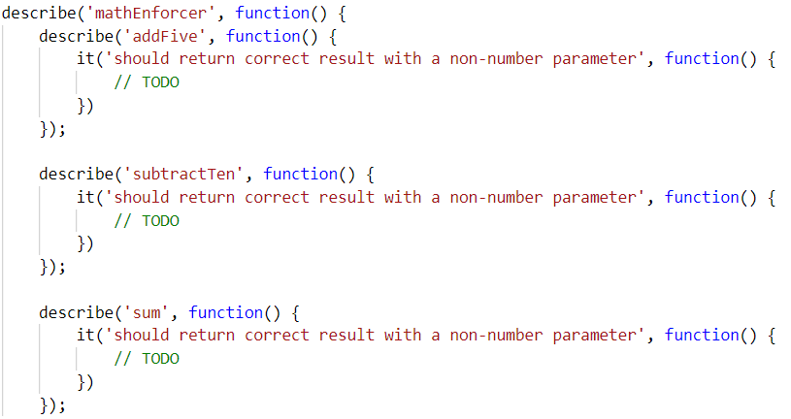

Your tests will be supplied with a variable named **"**mathEnforcer**"** which contains the mentioned above logic. All test cases you write should reference this variable.

### Hints

* Test how the program behaves when passing in **negative** values.
* Test the program with floating-point numbers (use Chai’s closeTo() method to compare floating-point numbers).

# DOM Error Handling

The following problems must be solved using DOM manipulation techniques.

**Environment Specifics**

Please, be aware that every JS environment may **behave differently** when executing code. Certain things that work in the browser are not supported in **Node.js**, which is the environment used by **Judge**.

The following actions are **NOT** supported:

* **.forEach()** with **NodeList** (returned by **querySelector()** and **querySelectorAll()**)
* **.forEach()** with **HTMLCollection** (returned by **getElementsByClassName()** and **element.children**)
* Using the **spread-operator** (**...**) to convert a **NodeList** into an array
* **append()** in Judge (use only **appendChild()**)
* **prepend()**
* **replaceWith()**
* **replaceAll()**
* **closest()**
* **replaceChildren()**
* Always turn the collection into a **JS array** (forEach, forOf, et.)

If you want to perform these operations, you may use **Array.from()** to first convert the collection into an array.

## Notification

Write a JS function that receives a string **message** and **displays** it inside a div with id "**notification**. The div starts **hidden** and when the function is called, **reveal** it. After the user clicks on it, **hide** the div. In the example document, a notification is shown when you click on the button ["**Get notified**"].

### Example

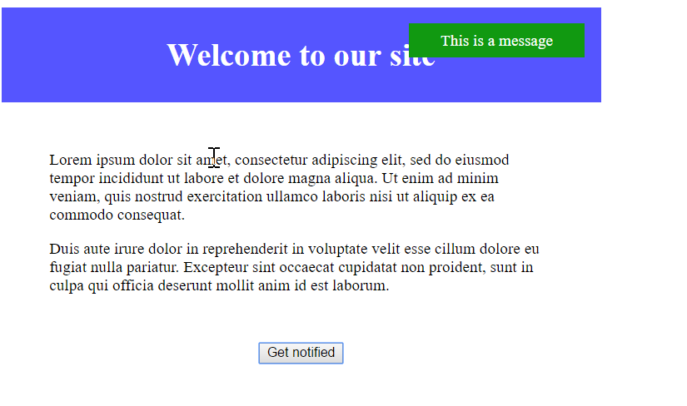

## Dynamic Validation

Write a JS function that dynamically validates an email input field when it is **changed**. If the input is invalid, apply to it the class "**error**". Do not validate on every keystroke, as it is annoying for the user, consider only **change** events.

A valid email will be in format: **<name>@<domain>.<extension>**

Only lowercase Latin characters are allowed for any of the parts of the email. If the input is valid, clear the style.

### Input/Output

There will be no input/output, your program should instead **modify** the DOM of the given HTML document.

### Example

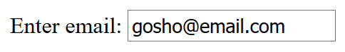🡪 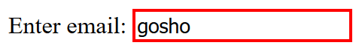

## Form Validation

You are given the task to write **validation** for the fields of a simple form.

### HTML and JavaScript Code

You are provided a **skeleton** containing the necessary files for your program.

The validations should be as follows:

* The username needs to be between **3** and **20** symbols **inclusively** and only **letters** and **numbers** are allowed.
* The password and confirm-password must be between **5** and **15** **inclusively** symbols and only **word characters** are allowed (**letters**, **numbers,** and **_**).
* The **inputs** of the password and confirm-password field **must match**.
* The email field must contain the “**@**” symbol and **at least one** "**.**"(**dot**) after it.

If the "Is company?" checkbox is checked, the CompanyInfo fieldset should become **visible** and the Company Number field must also be **validated**, if it isn’t checked the Company fieldset should have the style "display: none;" and the **value** of the Company Number field shouldn’t matter.

* The Company Number field must be a number between **1000** and **9999**.
* Use addEventListener() function to **attach** an **event listener** for the "change" event to the **checkbox**.

Every field with an **incorrect** value when the [Submit] button is **pressed** should have the following style applied border-color: red;, alternatively, if it’s correct it should have style border: none;. If there are **required fields** with an incorrect value when the [Submit] button is pressed, the div with id="valid" should become **hidden** (**"**display: none;"), **alternatively** if all fields are correct the div should become **visible**.

### Constraints

* **You are NOT allowed to change the HTML or CSS files provided.**

### Screenshots

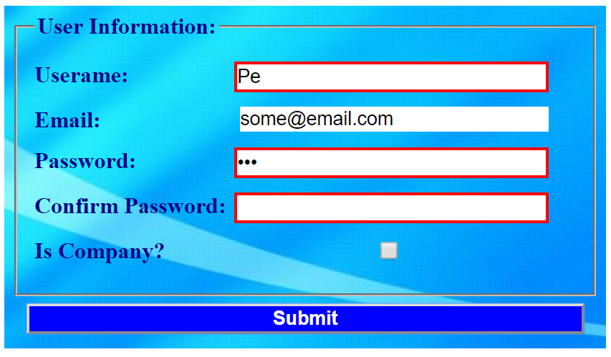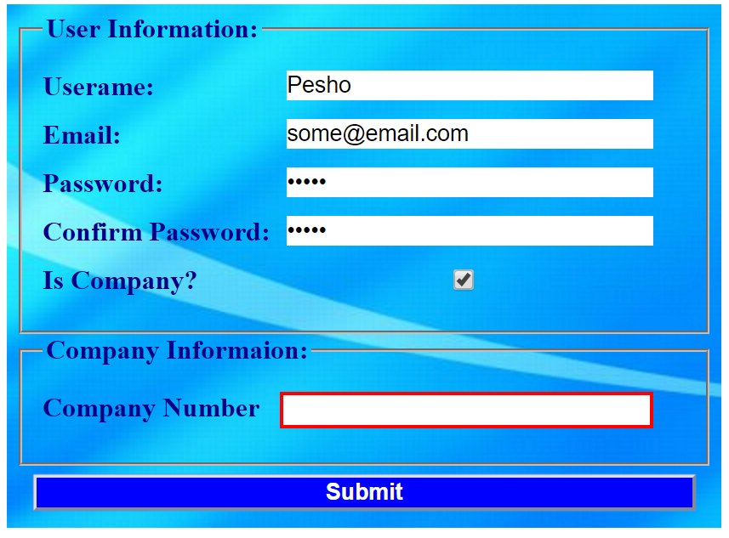

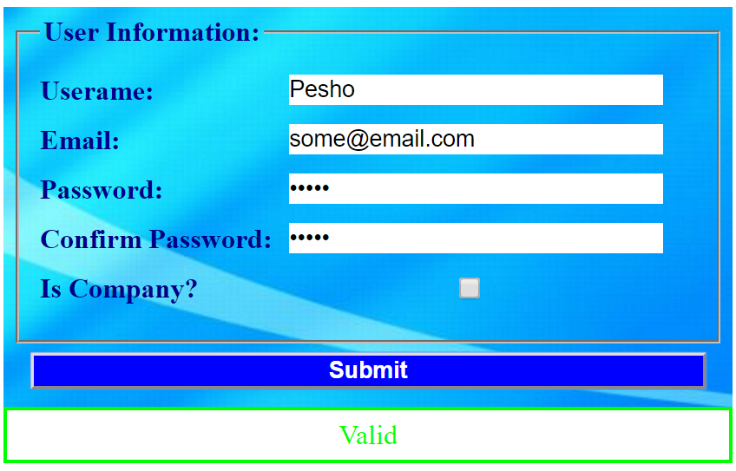

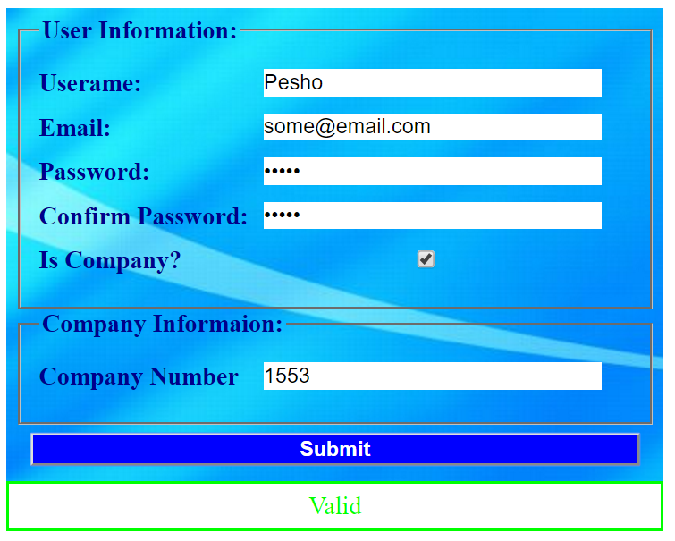

### Hints

* All buttons within an <form> automatically work as **submit** buttons, unless their type is **manually** **assigned** to something else, to avoid **reloading** **the page** upon **clicking** the [Submit] button you can use **event.preventDefault()**
* The validation for the separate fields can be done using **regex**.